EAST TIMOR SCOOTER DONATION

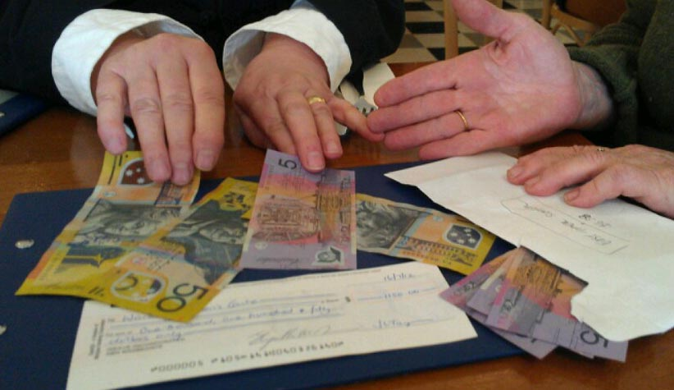

The Scooters for East Timor appeal raised $2,600, however, if you would like continue to donate to FOKUPERS this will greatly assist the work they are doing.
FOKUPERS works with survivors of domestic violence and sexual assault in East Timor. They provide refuge for women and children escaping domestic violence and incest, provide court support, run a childcare centre so women may work, offer small economic development programmes for women and they advocate for women on an individual and systemic level. East Timor is one of the poorest countries in Asia and remains very patriarchal. This makes the work of Fokupers all the more important, however they receive very little in the way of funding.
‘Women’s House’ opened the first women’s refuge in Brisbane in 1975. This was subsequently funded under the auspice of The Women’s Community Aid Association (WCAA). Women’s House now operates 2 services – The Brisbane Rape and Incest Survivors Support Centre and Women’s House Shelta.
We were fortunate enough to have the Director of Fokupers, Mery Barreto, visit here in August 2012. The Women’s Community Aid Association has offered to collect donations for Fokupers within Australia. As WCAA is registered as a charitable organisation, these donations will be tax deductible.
If you are interested in donating to FOKUPERS, you can make a tax deductible donation via the Women’s Community Aid Association by sending a cheque made out to:
1. The Women’s Community Aid Association
(mark on the reverse side that it is for Fokupers)
Post to: 15 Morrissey Street, Woolloongabba, QLD 4102
Please include your return address so that our finance worker can send you a receipt
or you can direct deposit into the following bank account:

2. WCAA
(please use your last name as a reference)
BSB: 064-131
A/c: 00902010
and then email finance@brissc.org.au to indicate that you have made a donation to Fokupers. A tax receipt will then be sent to you via return email.

